TASK 5

PART-1

DONE BY

NAVANEETHAN.S

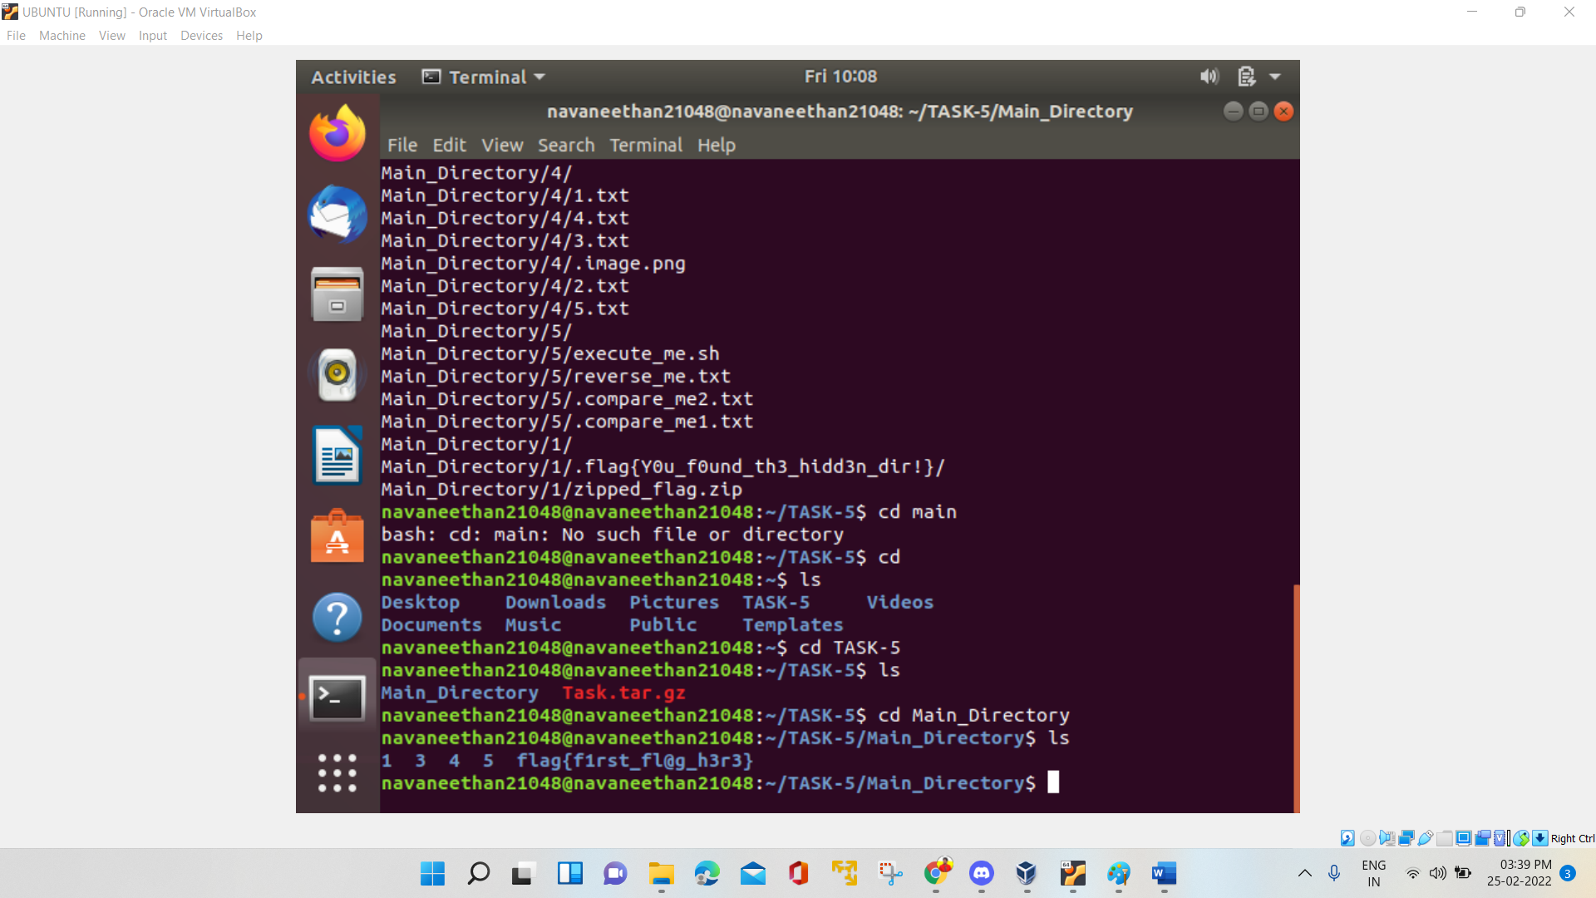FLAG 1: flag{f1rst_fl@g_h3r3}

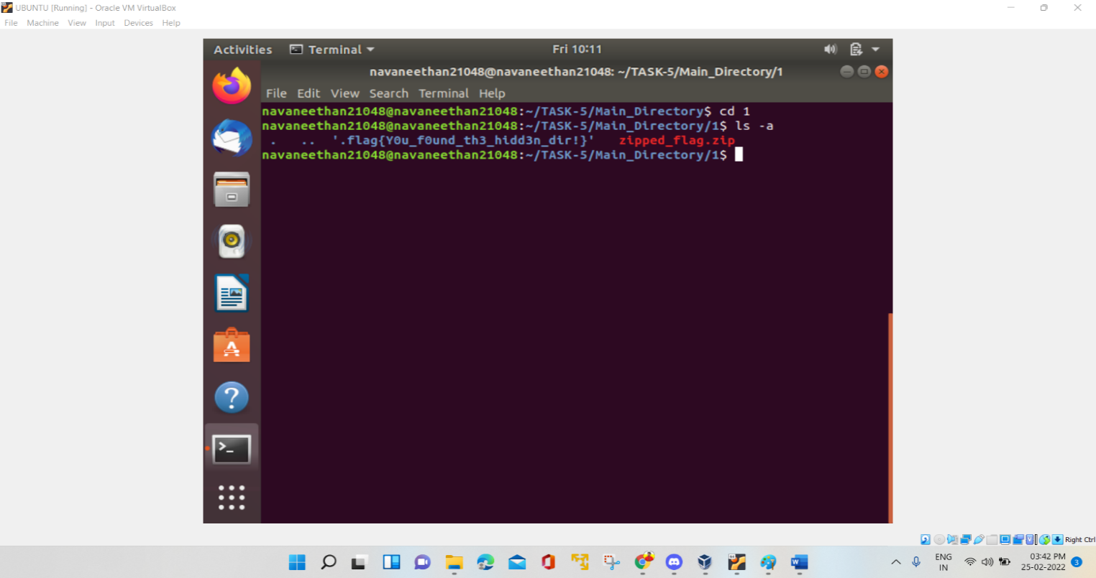FLAG 2: flag{Y0u_f0und_th3_hidd3n_dir!}

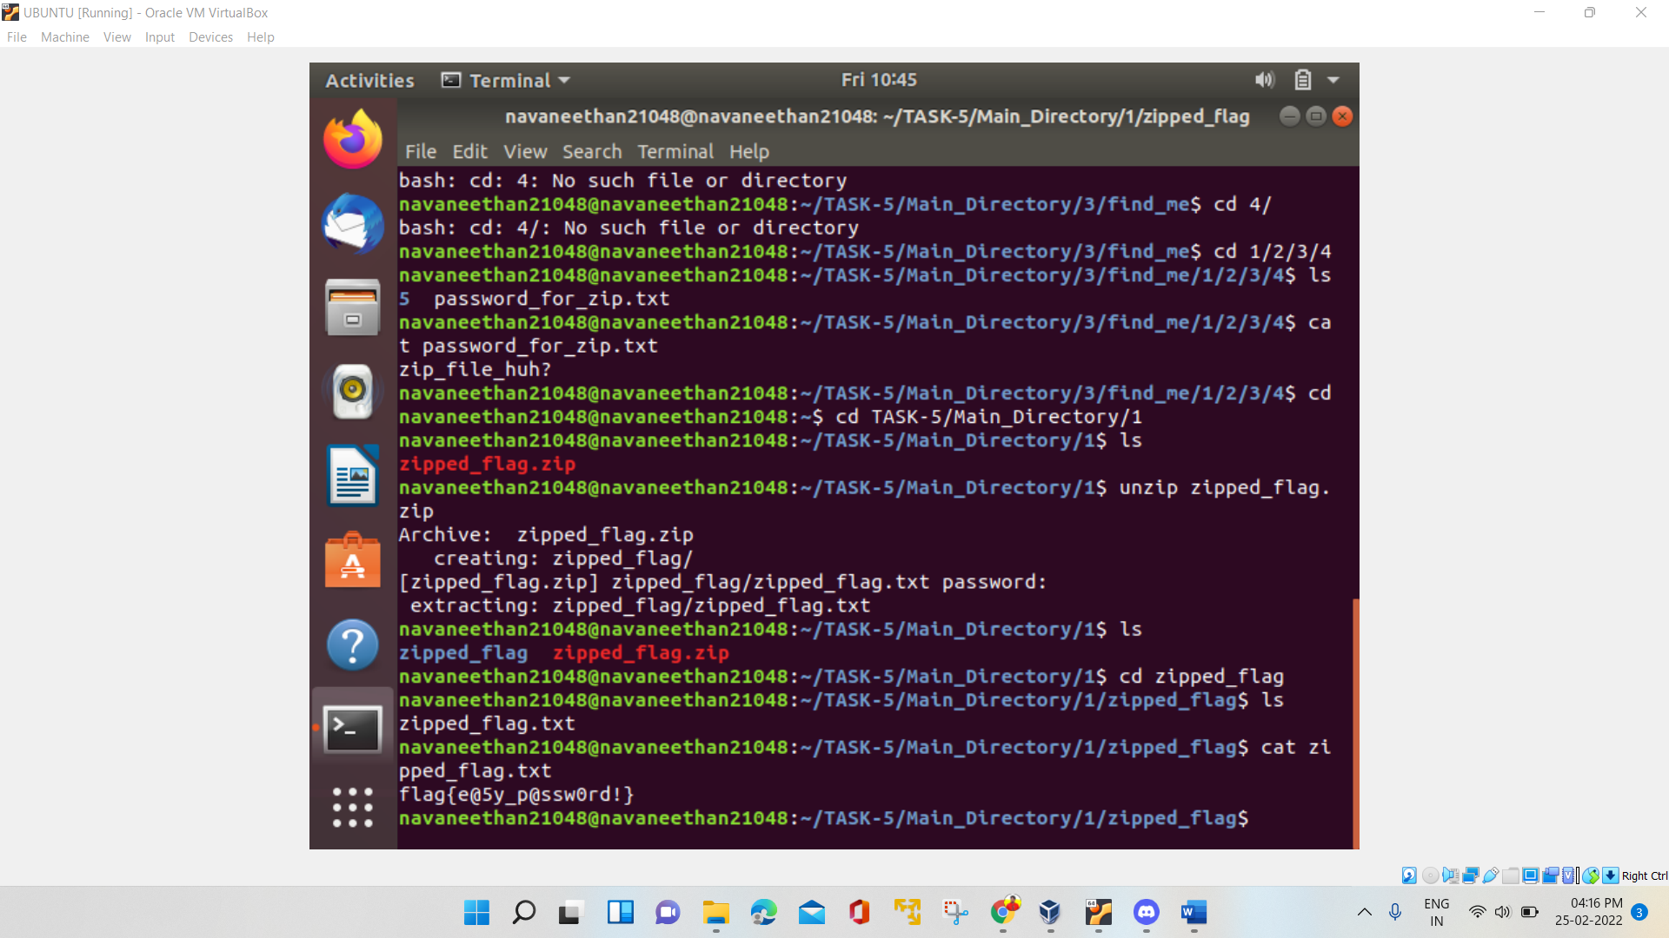FLAG 3: flag{e@5y_p@ssw0rd!}

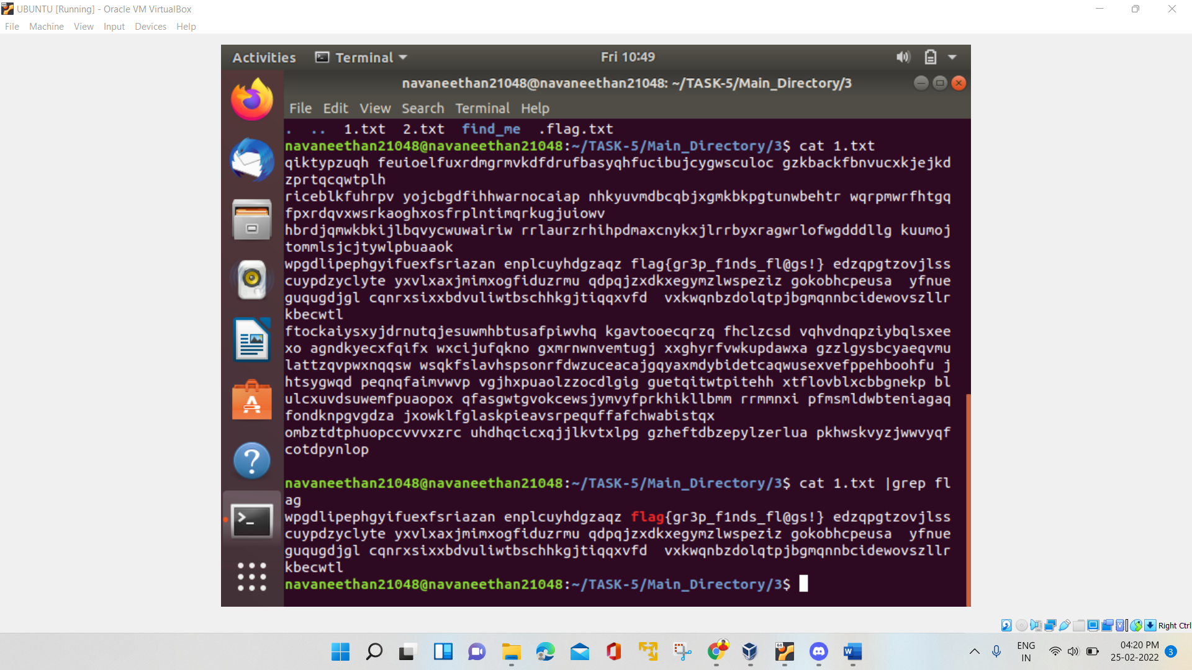FLAG 4: flag{gr3p_f1nds_fl@gs!}

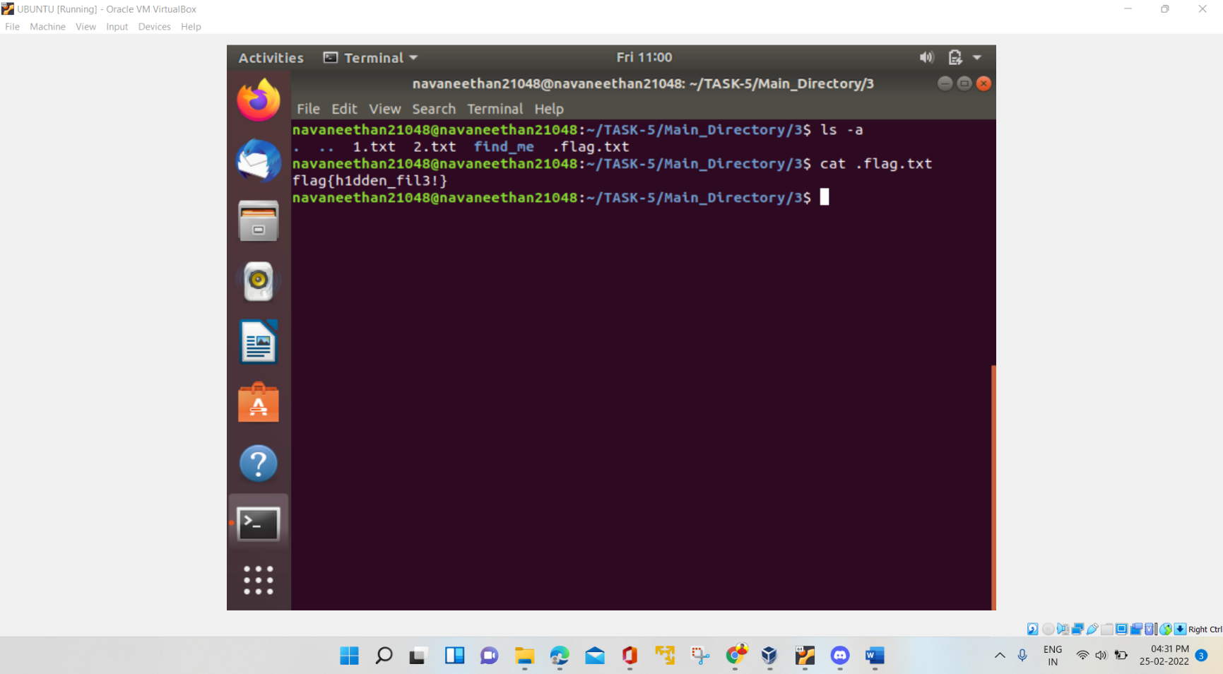FLAG 5: flag{gr3p_f1nds_fl@gs!}

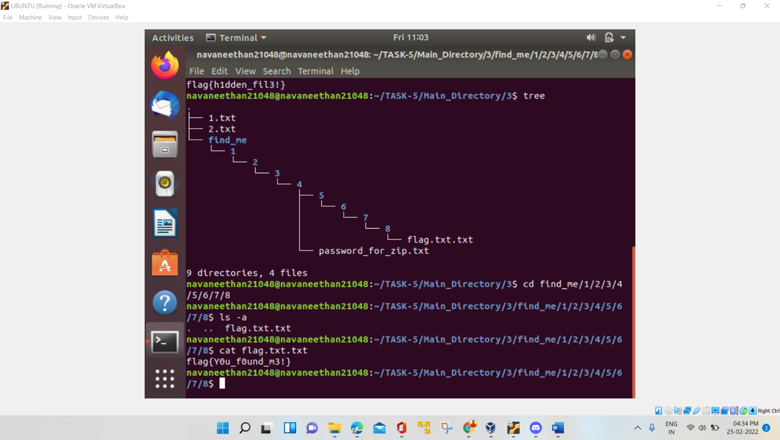FLAG 6: flag{Y0u_f0und_m3!}

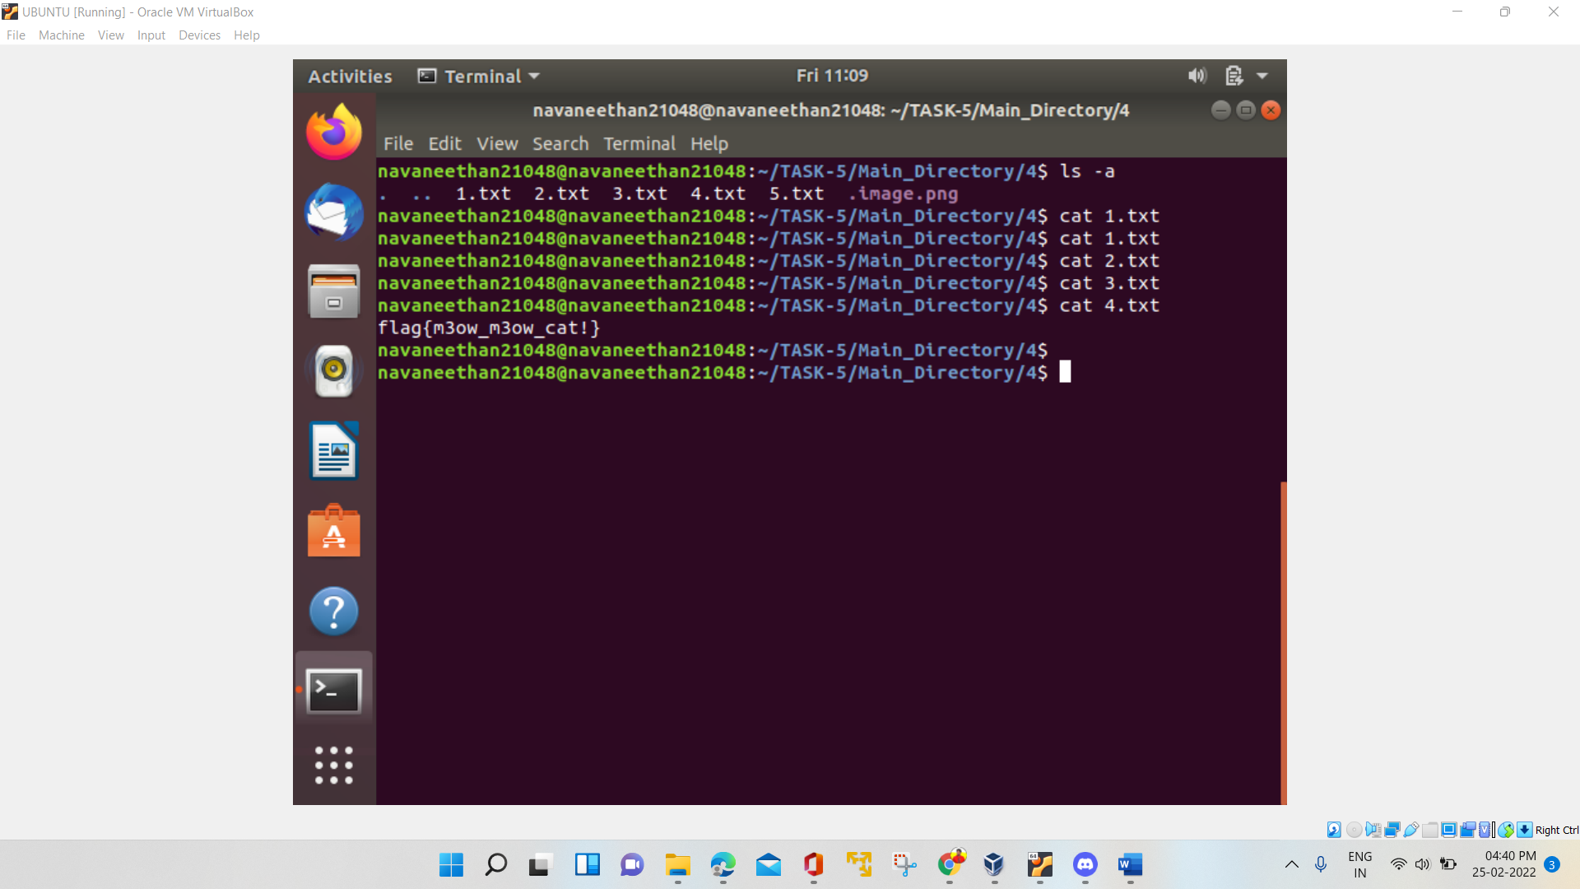FLAG 7: flag{Y0u_f0und_m3!}

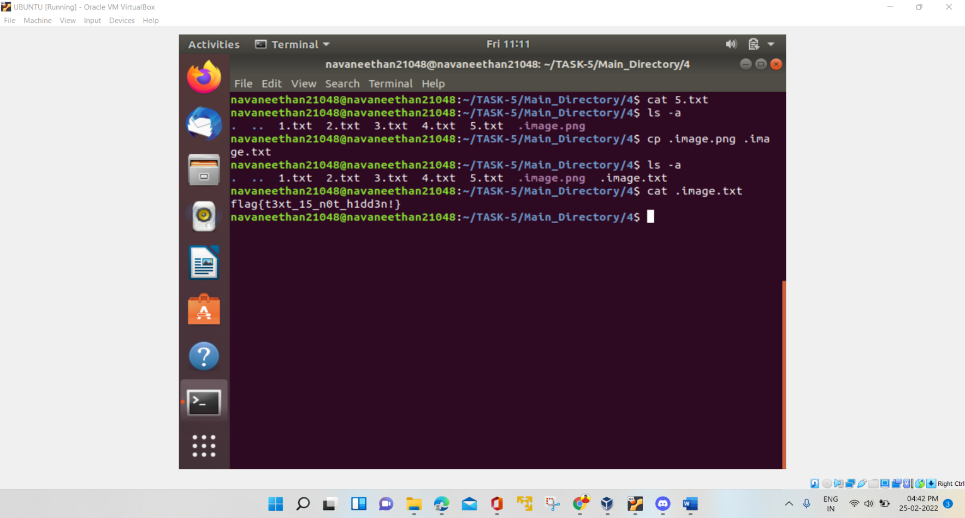FLAG 8: flag{t3xt_15_n0t_h1dd3n!}

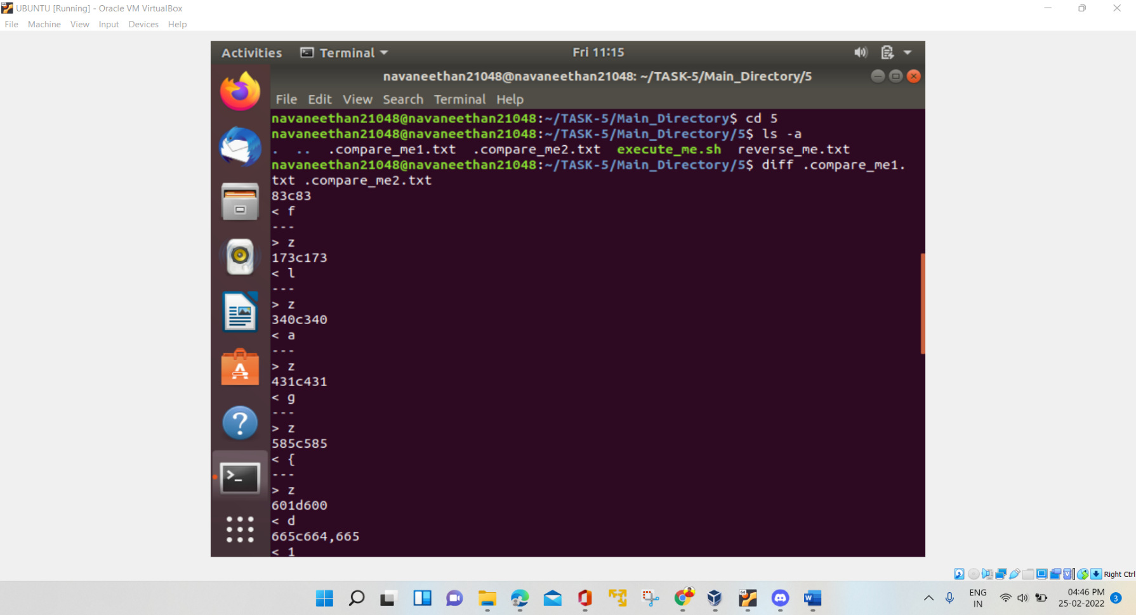FLAG 9: flag{d1ff_15_u53_ful!}

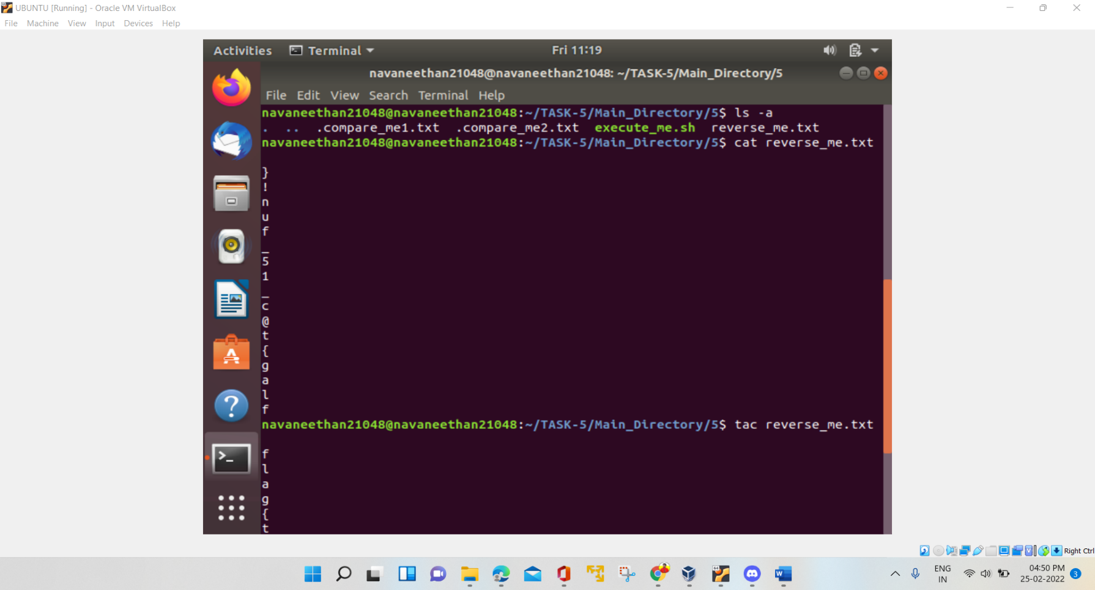FLAG 10: flag{t@c_15_fun!}

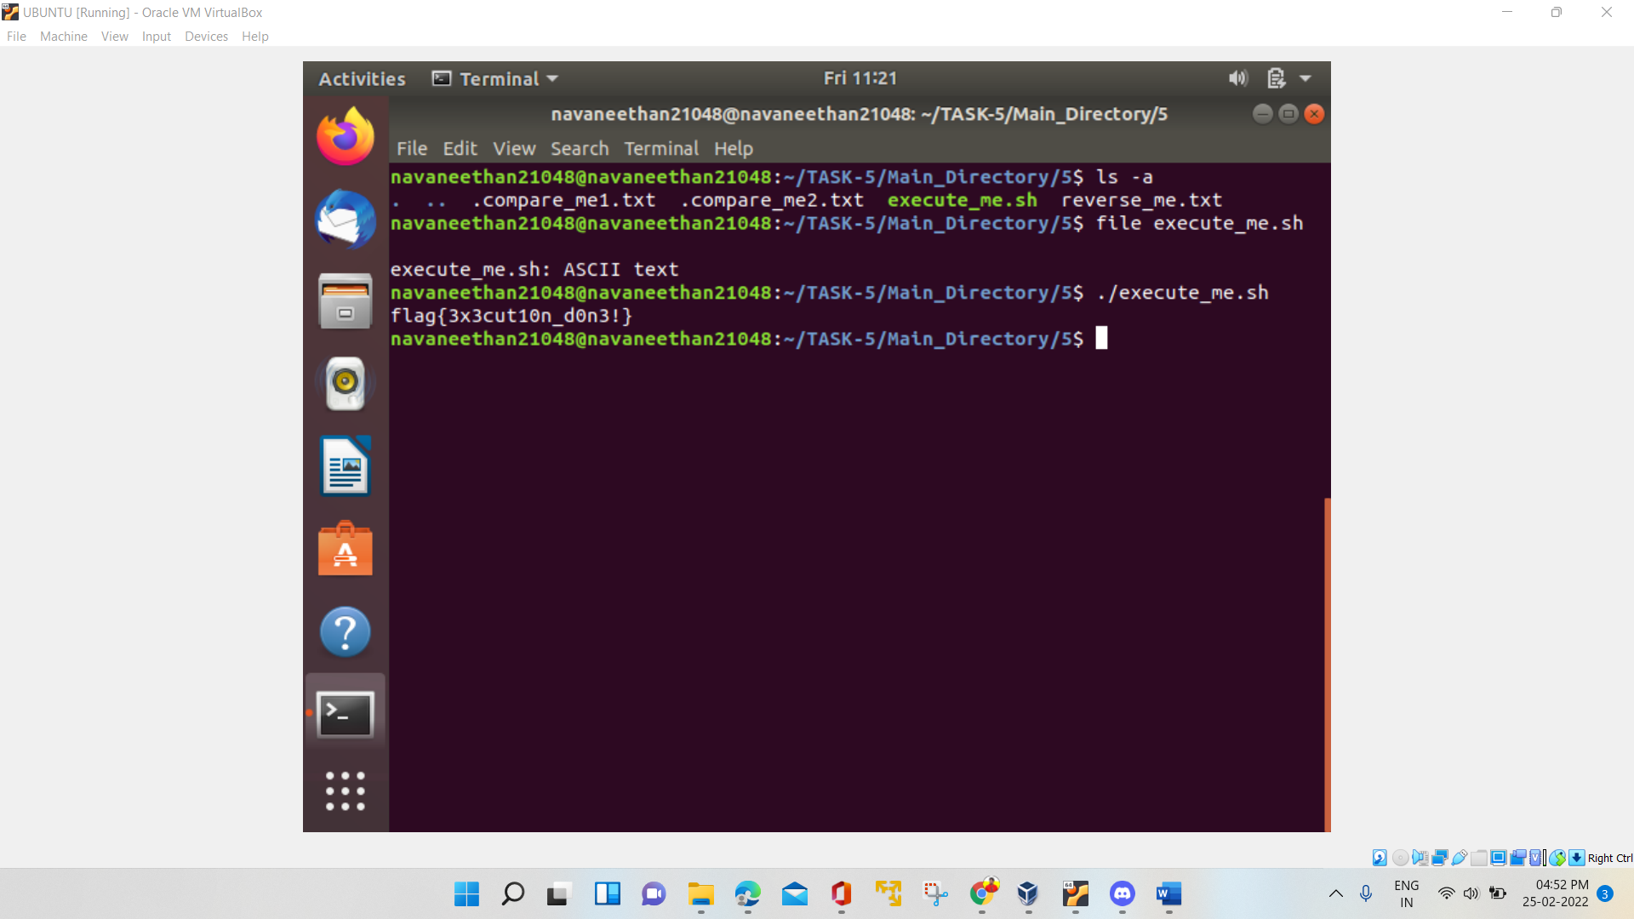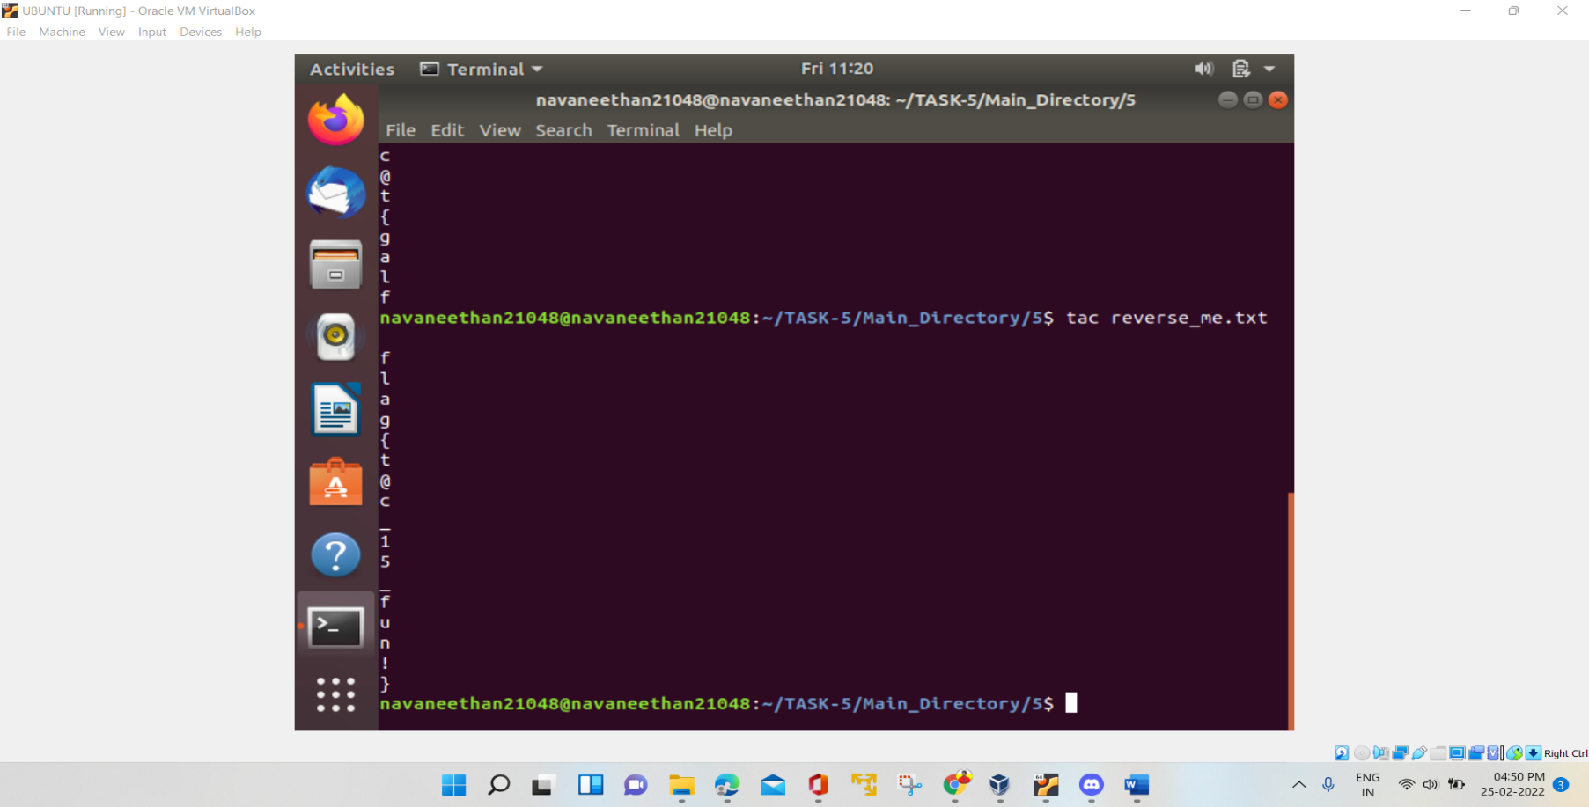FLAG 11: flag{3x3cut10n_d0n3!}